Client # |  | Date of Birth | / /
Name
Address
Mobile # |  | Other (Home / Work)
Email Address
Next of Kin |  | Contact #
Relationship |  | Confidentiality Clause Signed? | (office use only)  Yes / No
_ _ _ _ _ _ _ _ _ _ _ _ _ _ _ _ _ _ _ _ _ _ _ _ _ _ _ _ _ _ _ _ _ _ _ _ _ _ _ _ _ (Cut here and file separately)
Client # |  |  | Age
Name |  |  | Identify as |  | M / F / L / G / B / T
Confidentiality | “I need to inform you that everything that you say here is completely confidential unless of course I think you are going to be a danger to yourself or someone else. Is that OK with you?”  I, _______________________________ give my consent to the terms of confidentiality outlined above.
Client Signature | Date: / /
Reason for seeking counselling
When did you and your partner meet? | Date Met:  # of Years Together | Marital Status |  |  | - Single  - De Facto  - Married  - Divorced  - Separated
Marriage Date

________________
Country of Birth |  | Years in Australia
Occupation
Living situation | Self Partner Children  Parents Shared House Other
Do you have children of your own? | How many children (including deceased, terminated, miscarried etc):  Names and Ages of each child:
Family of Origin: Number of Children |  |  |  | Position in Family: e.g. 1 for first born
Who is on your TREATMENT TEAM e.g. GP, psychologist, psychiatrist, acupuncturist etc
 | Name and Contact Number: |  |  | Name and Contact Number:
Medication Yes / No | Type and dosage: |  |  | Type and dosage:
Health Concerns | - Chronic Pain  - Digestive Issues  - Diagnoses e.g. Fibromyalgia; Other_____________________________________  - Asthma  - Injuries ______________________________________
Recreational drug intake |  |  |  | Recommended by:  Referral / LECNA ER Walk-in  Google Ad / Search WoMouth  Email Website  Flyer / Mail drop Other
Anything else I should know? | Anything that you would like me to be aware of that will affect our time together in session  i.e. addictions, mental health issue e.g. anxiety, depression, disorders (bipolar etc), polyamory, sexual abuse, domestic violence – previous relationships etc
Sleep | Able to sleep 6-8 hours per night? Y/N  Difficulty getting to sleep? Y/N  Difficulty staying asleep? Y/N
Newsletter | Would you like to receive our infrequent newsletter – contains tips, tricks and techniques around Relationships, and Mental Health. Y/N
Please draw your family tree here:
FAMILY NAME: _____________________________________________________________________
Your Father

Age:

Alive: Y/N

Age:

Your Mother

Alive: Y/N

Cause of Death:
______________
Marital Status
- Together
- Divorced
- One Partner Deceased

Repartnered: Y/N
FA: Defacto/remarried?
MO: Defacto/remarried?
Cause of Death:
______________

Your Siblings (Brothers, Sisters, Half siblings etc) Alive or dead, terminated or miscarried etc

Please indicate using square for males, and circles for females, the names, ages and birth order of your siblings of your own biological family, in the space below.

Presenting Issues

Issues | - Addictions
- Abuse
(Physical or Emotional or Sexual – please circle)
 | - Affairs & Infidelity (Physical)
 | - Alone Together
- Jealousy & Betrayal
– Real/Perceived or Virtual (please circle)
 | - In-laws
 | - Intimacy Issues
 | - Lack of Boundaries
 | - Mental Illness
 | - Negative Communication
 | - Not Attracted to Partner
 | - Parenting Styles don’t match up
 | - Regrettable Incidents
 | - Staying Together for the Kids
 | - Trust Issues
 | - Unmet Emotional Needs
 | - Unsolvable Problems
 | - You are not on your partner’s side
 | - Mid-life Crisis
 | - Virtual betrayal (online, chatrooms, social media)

Basic Timeline
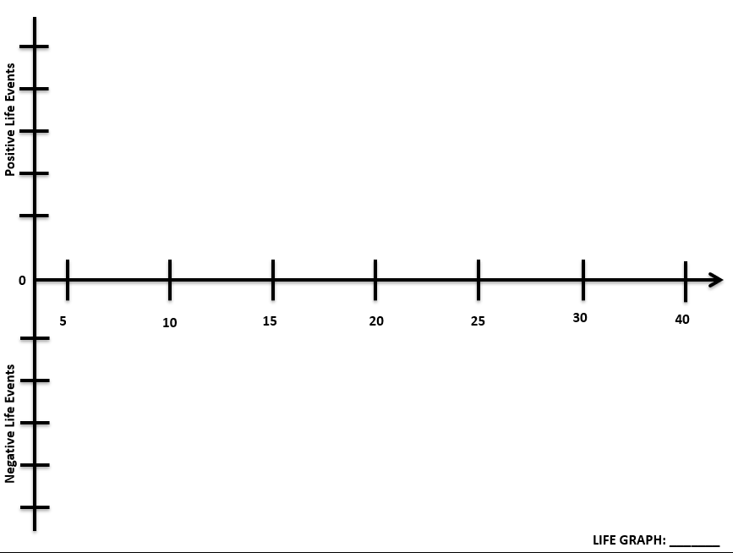
INSTRUCTIONS EXAMPLE
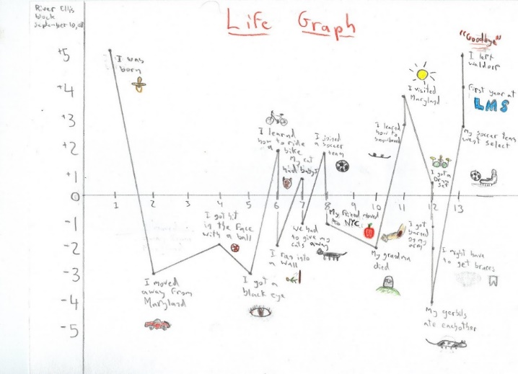
- Brainstorm a basic list of memories from your couple life that sticks out e.g. Met, Committed, Married, Moved in, Divorced, Remarried etc
- These events might be big (met my first romantic love) or small (got my first dog).
- They might be positive (when you got your first A in school) or negative (when your something you really loved died e.g. a goldfish, dog).
- Take these events and create a Life Graph use a dot to indicate on the graph what age this occurred at, and whether it was a positive or negative experience for you. Label the dot.
- Each notch on the horizontal timeline represents 5 years in chronological order. If you like, include a symbol or a graphic, if you like drawing.

